Obect Oriented Design Patterns
Lab Sheet – Week 6

Exercise 1

Create a new project called Lab6Part1. You have been supplied with a Hierarchy of classes of Animals in a Jar file called ZooCode_Missing_Adapter.jar. All of the classes inside this Jar file are part of the same animal hierarchy and are all designed to use a polymorphic feed() method so that the feeding instructions for all animals can be output in the same way using dynamic binding. IMPORTANT: The code is missing two classes called LizardAdapter.java and AlligatorAdapter.java which should be Adapter classes to call a feed() method for Lizards and Alligators.
You have also been supplied with a second Jar file called LizardAndAlligator_Code_Supplied.jar. This jar file contains a previously written lizard.java and alligator.java class which has the feeding instructions for Lizards and Alligators BUT DOES NOT CONFORM TO THE INTERFACE OF THE ANIMAL HIERARCHY IN THE ZooCode_Missing_Adapter.jar file; instead the lizard and alligator classes use methods called feedLizard() and feedAlligator() [TO CONFORM TO THE ANIMAL INTEFACE THEY SHOULD CALLED feed() )

You have DELIBERATELY not been given the source code for lizard and alligator classes, instead only the .class files has been supplied: YOU MUST NOT WRITE A NEW LIZARD AND ALLIGATOR CLASS AND YOU WILL NOT BE SUPPLIED WITH THE LIZARD AND ALLIGATOR CLASS SOURCE CODE (you will need to import this Jar into your zoo project; do this using Project->Properties->Libraries (tab)->Add External Jar and include the LizardAndAlligator_Code_Supplied.jar into your project).

YOUR TASK: Make the lizard AND alligator class that was supplied work with the Animal hierarchy by using the Adapter design pattern. This will involve writing the missing LizardAdapter and AlligatorAdapter classes within the Animal hierarchy and calling the Adaptee’s non-complying feedlizard() and feedalligator() methods from a compliant feed() method in the new adapter classes. [Hint: You will know when this is working you will see what type of food the lizard and alligator eats without ever having needed to see the original source code!!!]

- Create the LizardAdapter class
- Create the AlligatorAdapter class
- Test the program and verify type of food for both animals

Exercise 2 (Past Exam Question)

The following example allows the user to display points, lines and squares.
In designing the system, the designer decided to include these shapes in a higher level concept that could be called a ‘displayable shape’.
To accomplish this, the designer created a shape class and then derived from it the classes that represented points, lines and squares (see fig below).
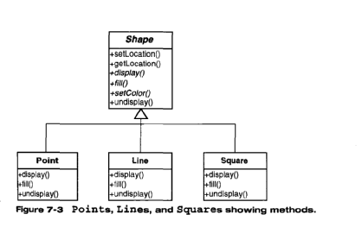
After implementing the above system, the designer was then asked to include a class that could draw triangles. This class should also contain all of the required methods such as display(), fill() and undisplay().
The designer then discovered that a colleague had written a triangle class that perfomed the exact tasks required. Unfortunately the methods within this class were called displayIt(), fillIt(), undisplayIt().
- Using the Adapter pattern, explain in a step-by-step fashion how you would incorporate the given ‘triangle’ class into the above system.

- Draw an accurate UML diagram that reflects the updated system.

- Provide a Java code fragment for the class ‘triangle’ that implements the Adapter pattern.

